A. Create your subgroup and project in GitLab using the provided web link and the "GitLab How-To" web link by doing the following:
• Clone the project to the IDE.
• Commit with a message and push when you complete each requirement listed in parts B, C, D, and E.
Note: You may commit and push whenever you want to back up your changes, even if a requirement is not yet complete.
• Submit a copy of the GitLab repository URL in the "Comments to Evaluator" section when you submit this assessment.
• Submit a copy of the repository branch history retrieved from your repository, which must include the commit messages and dates.
B. Write a script in either Python or R to import the data you downloaded and format it according to the criteria required by the model script, demonstrating a progression of work on your code. You must run a DVC command to create a metafile for your dataset and submit the metafile to the GitLab repository. Submit at least two versions of your code to the GitLab repository demonstrating a progression of work on your code.

Note: Include the original CSV file you downloaded in your GitLab repository. Although data files are not typically stored in GitLab repositories, including this file in your submission is necessary to allow evaluators to fully assess your work.
C. Write a script in either Python or R to filter data to only departures from the chosen airport, then implement at least two other data cleaning steps. Submit at least two versions of your code to the GitLab repository demonstrating a progression of work on your code.
D. Using the code template provided in the GitLab repository, implement an MLFlow experiment that captures the features listed in the comments within the poly_regressor file for either Python or R. Submit at least two versions of your code to the GitLab repository demonstrating a progression of work on your code.
E. Using the provided YAML file for either Python or R, write an MLProject file that links the two scripts you wrote in parts B and C with the modified poly_regressor script from part D.
Note: Your MLProject file must be submitted to the GitLab repository.
F. Provide a written explanation of how you wrote the code and MLProject pipeline, including any challenges you encountered and how you addressed these challenges. Include a screenshot of your MLProject pipeline running successfully.
1. import_data.py– Handles raw data import.
2. clean_data.py– Cleans and filters the imported data.
3. poly_regressor_Python_1.0.0.ipynb– Trains and evaluates a polynomial regression model, logging all results and artifacts with MLflow.
I then created an MLproject file to orchestrate these steps using MLflow, ensuring that each stage could be run independently or as part of a pipeline.
- import_data.py Reads the raw CSV, performs basic validation, and saves a standardized output file.
- clean_data.py Loads the imported data, applies filtering (e.g., only JFK departures, removes missing/duplicate rows), and saves the cleaned dataset.

Both scripts accept input and output file paths as command-line arguments, making them flexible for pipeline integration.
2. Model Training and Evaluation
- poly_regressor_Python_1.0.0.ipynb:
- Loads the cleaned data.
- Performs feature engineering (e.g., time formatting, one-hot encoding).
- Splits data into training and test sets.
- Trains a Ridge regression model with polynomial features, tuning the alpha parameter.
- Evaluates the model and logs all relevant metrics, plots, and artifacts to MLflow.
- Saves the trained model and experiment URI for reproducibility.

3. MLProject Pipeline

I wrote an MLproject file referencing the provided pipeline_env.yaml for environment consistency.
Each script is defined as an MLflow entry point with parameters for input/output paths.
The notebook is executed using `papermill` to allow parameterization and reproducibility.
Challenges and Solutions
1. Parameter Passing to Notebooks:
Notebooks are not natively parameterized. I used `papermill` to inject parameters into the notebook, allowing it to be run as part of the MLflow pipeline.
2. Artifact and Metric Logging:
Ensuring all relevant files (logs, plots, encodings, model files) were logged as MLflow artifacts required careful tracking of file outputs and explicit logging commands.
3. Data Consistency Across Steps:
To avoid mismatches, I standardized input/output filenames and ensured each script could accept parameters for file paths.

c9375f3 (HEAD -> main, origin/main, origin/HEAD) updated the MLflow experiment
bfcb113 Added MLproject file
d841128 performed one hot encoding for all destination airports in training data
4130d92 Fixed dataframe column names and updated training model code to use correct columns
7243809 Track original dataset with DVC
d257793 Add notebook and original data file
3b2cafc Initial import script and raw data
51f2d51 Add dataset to DVC tracking
9a8612f Initialize DVC
1005eec Added commit history file as d602task2_commit_history.txt
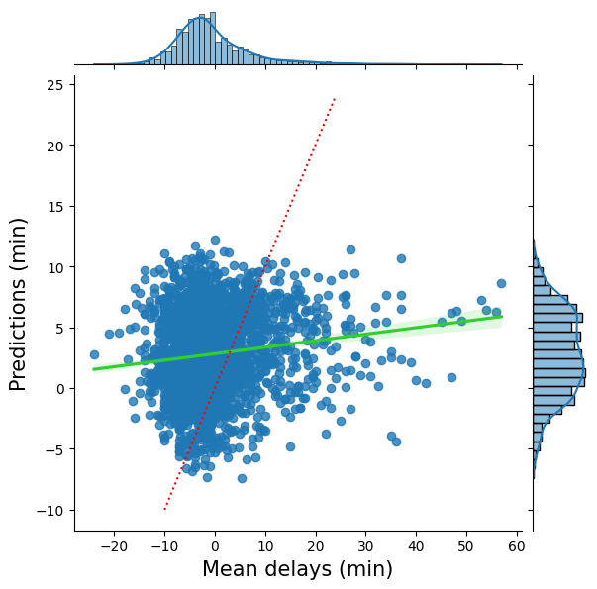
G. Acknowledge sources, using in-text citations and references, for content that is quoted, paraphrased, or summarized.
No sources were used.
H. Demonstrate professional communication in the content and presentation of your submission.

